

Draw It or Lose It

# **CS 230 Project Software Design Template**

Version 1.0

## Table of Contents

**CS 230 Project Software Design Template**1

**Table of Contents**2

**Document Revision History**2

**Executive Summary**3

**Design Constraints**3

**System Architecture View**3

**Domain Model**3

**Evaluation**3

**Recommendations**5

## Document Revision History

| Version | Date | Author | Comments |
| --- | --- | --- | --- |
| 1.0 | 07/18/21 | Ashley Santo | Updated the following sections: Executive Summary, Design Constraints, and Domain Model |
| 1.0 | 07/31/21 | Ashley Santo | Updated the Evaluation section |
| 1.0 | 08/14/21 | Ashley Santo | Updated the Recommendation section |

## Executive Summary

The Gaming Room would like to develop a web-based game that serves multiple platforms. They would like the game to be based on their game, Draw It or Lose It. This game is currently only available as an Android application. There are also requirements The Gaming Room would like implemented including: multiple teams playing, having multiple people on a team, unique game and team names, and only one instance of the game can exist through unique identifiers.

## Design Constraints

Requirements include:

* Having one or more teams involved
* Multiple players assigned to each team
* Unique game and team names
* Users can check whether name is in use
* One instance of the game at a given time
* Use unique identifiers for each instance of game, team or player

The design constraints would include more than just the software requirements above. They would also include the application development process. The game needs to be able to run across multiple different devices. While it is already available for android, it would need to be available for other mobile devices and computer operating systems (Windows, Mac, Linux). In order to do this, the code will need to be either written in multiple languages for the different systems or we would need to make sure to use IDE environments that can be used to develop games for multiple platforms (such as Unity or Unreal). Depending on the option we take, it may slow down development of the application.

## System Architecture View

Please note: There is nothing required here for these projects, but this section serves as a reminder that describing the system and subsystem architecture present in the application, including physical components or tiers, may be required for other projects. A logical topology of the communication and storage aspects is also necessary to understand the overall architecture and should be provided.

## Domain Model

The UML class diagram below is a visual to explain how classes will be implemented into the program and what their relationship is with each other. We can object oriented principles in multiple ways. First, there is inheritance. The class Entity would be the parent class in this case and the child classes (Game, Team and Player) will inherit the class attributes it contains. The ProgramDriver uses the SingletonTester in order to make sure there is only one instance of the game at any time. The GameService class is associated with Game, which is then associated with Team, which in turn is associated with Player. They all share a zero to many relationship where the attributes of that class are optional to making the other classes connected to it run. Encapsulation can also be seen in the Entity and GameService classes where they contain private methods that can not be touched by any outside methods.

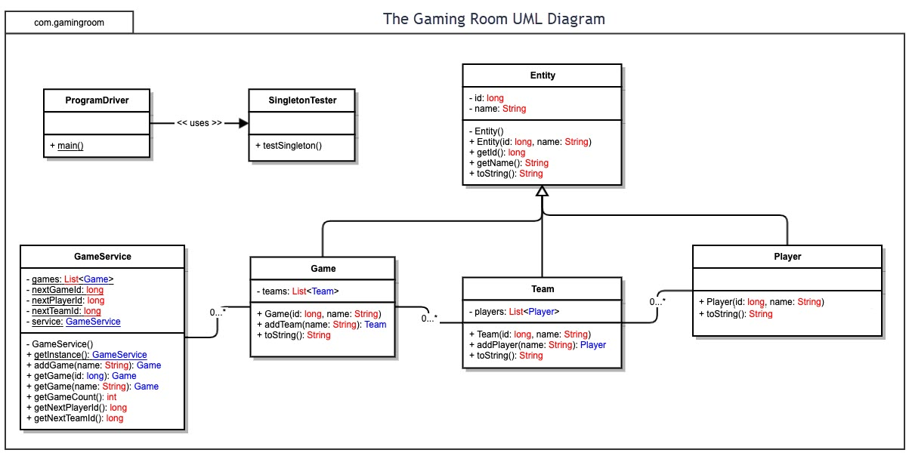

## Evaluation

| **Development Requirements** | **Mac** | **Linux** | **Windows** | **Mobile Devices** |
| --- | --- | --- | --- | --- |
| **Server Side** | Easy terminal with convenient commands, top of the line hardware, and high levels of security. Also has easy accessibility and server configuration. Does come at a very high cost. | Uses open-source software giving multiple host options. Does offer relatively safe security and is usually cheaper. Linux is more difficult to use compared to other OS’s. | Easy to use, user friendly, and most supported OS with plenty of software options. Also, can be pricey. Due to its larger use, security can be an issue. | Minimal software support. Becomes difficult if IP changes with location or phone dies. Slower to access. It is cheaper than other hosting options. |
| **Client Side** | Users require moderate expertise to use OS as well as time to learn. Tends to be expensive. | Require extreme expertise to master using this OS which in turn requires time. Cheap cost for users. | Users don’t need much time or expertise to use as it has a very friendly UI. Cost is anywhere from low to high end. | This can be anywhere from minimal to moderate expertise depending on the device and might take some time. Costs can be low to high as well. |
| **Development Tools** | IDEs that can be used include: Visual Studio, PyCharm, Eclipse, etc. are all compatible with Mac. Languages can include: Swift, JavaScript, Python, CSS, HTML, and Java | IDEs that can be used include: Visual Studio, PyCharm, Eclipse, Netbeans, Atom etc. are all compatible with Linux. Languages can include: JavaScript, Python, CSS, HTML and Java | IDEs that can be used include: Visual Studio, PyCharm, Eclipse, Netbeans, Atom, etc. Languages can include: JavaScript, Python, CSS, HTML, C languages, Java and PHP | IDEs that can be used include: Android Studio, Visual Studio, Eclipse and IntelliJ. Languages can include: Swift, JavaScript, Python, CSS, HTML, C languages |

## Recommendations

Analyze the characteristics of and techniques specific to various systems architectures and make a recommendation to The Gaming Room. Specifically, address the following:

1. **Operating Platform**: The operating platform I would suggest is Windows. As one of the most used OS’s out there, Windows is a widely supported operating system that is user friendly for client and server side and doesn’t usually come at a steep cost. It also offers plenty of support to developers with many different developmental tools.
2. **Operating Systems Architectures**: Windows is a very versatile OS allowing clients and developers to customize it to fit their needs. It has an extensive file system and allows memory management. The command prompt is a tool that allows the user to configure the system as needed. Also, the graphical user interface is extremely simple to use and is compatible with most programs.
3. **Storage Management**: Windows allows control over storage management in a very simplistic way. Users can add storage to the system as well as partition and control how things are being stored. The file system makes it easy to control where files are being saved and to which storage areas. Windows also has a feature called Storage Sense that allows users to detect unnecessary files and create more space. They also offer cloud options that can be used through Windows but there are always third-party cloud options as well.
4. **Memory Management**: Windows offers physical and virtual address space that allows up to four gigabytes of memory. Virtual memory allows the system to have a solution when it is experiencing memory shortages. It can swap data to a physical storage device when not in use which frees up memory without having to add more.
5. **Distributed Systems and Networks**: Distributed systems and networks offer easy communication and coordination between stations. This also allow users the ability to communicate with different servers that need to be accessed. That being said, there can still be failure of individual components in the network/systems and congestion problems if many people are trying to access the same server. The company will need to make sure there are enough servers to handle the volume of players expected to join. If not, this could lead to extreme lagging and connectivity issues. Addressing server issues is crucial as if servers crash, it can cause outages for long periods of time.
6. **Security**: Windows itself comes with security software built-in to the system. Starting with user accounts where usernames/passwords are required to access the system. It also comes installed with Windows Security which offers a multitude of different security features. There is virus and threat protection, firewall and network protection, device security and device performance and health. It’s also up to the company to make sure access to personal information is only being allowed to certain users through user permissions. With cloud storage, it’s best to keep in mind that the company will be dependent on the cloud service provider to make sure data is staying secure.